FACULTY EVALUATION
Programme Name: Social Entrepreneurship Development Program (SEDP)- Advance Uganda (2nd March 2026 - 6th March 2026)
Session: Governance and Succession Planning
Faculty Name: Dr. Tom Buringuriza
No. of Respondents: 9
No. of Participants: 10
Evaluation Parameter | (%) Individual Score | (%) Programme Average
Punctuality (Commencement and Completion of Sessions) | 100 | 91
How well do you understand the core concepts presented? | 91 | 92
Rate your confidence in applying the new skills learnt | 89 | 87
Degree of Faculty preparedness for the sessions | 100 | 97
Content and methodology of the program | 100 | 95
Quality of class and group discussions | 93 | 89
The information presented in the course is relevant to my work (ministry) | 100 | 97
Average scores | 96 | 93

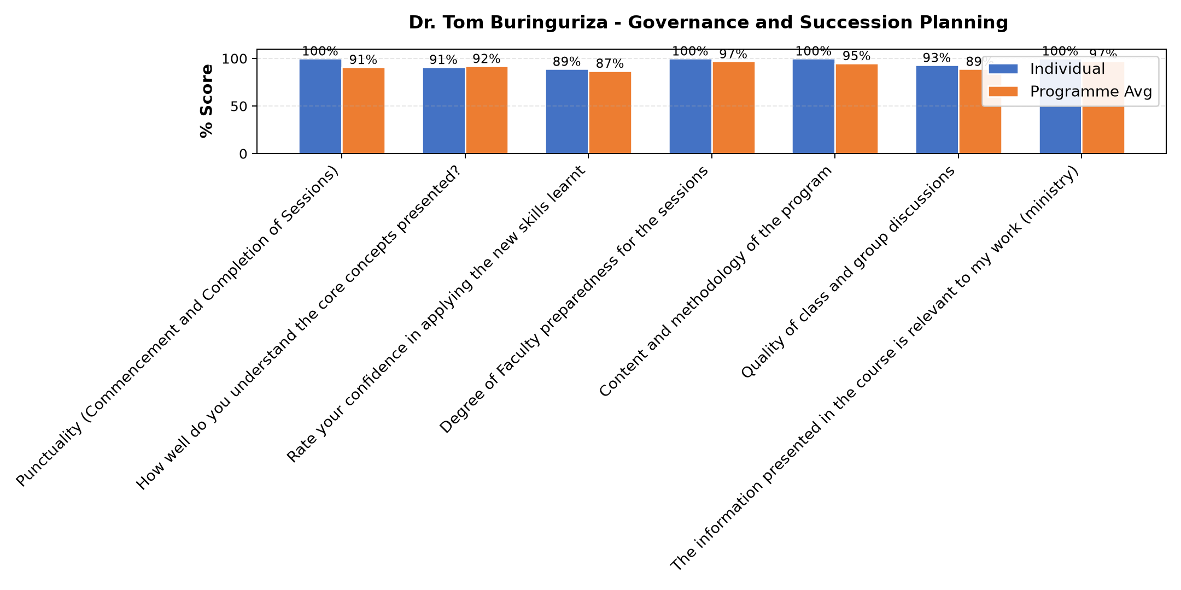

Comments & Feedback
- • Deeper knowledge of the importance of some taxes
- • Good presentations
- • The lecturer took us from a lay man and a beginner perspective that made us got the concept of Governance and succession planning very well.
SUBMITTED THROUGH:
SBS Evaluation Automation System

